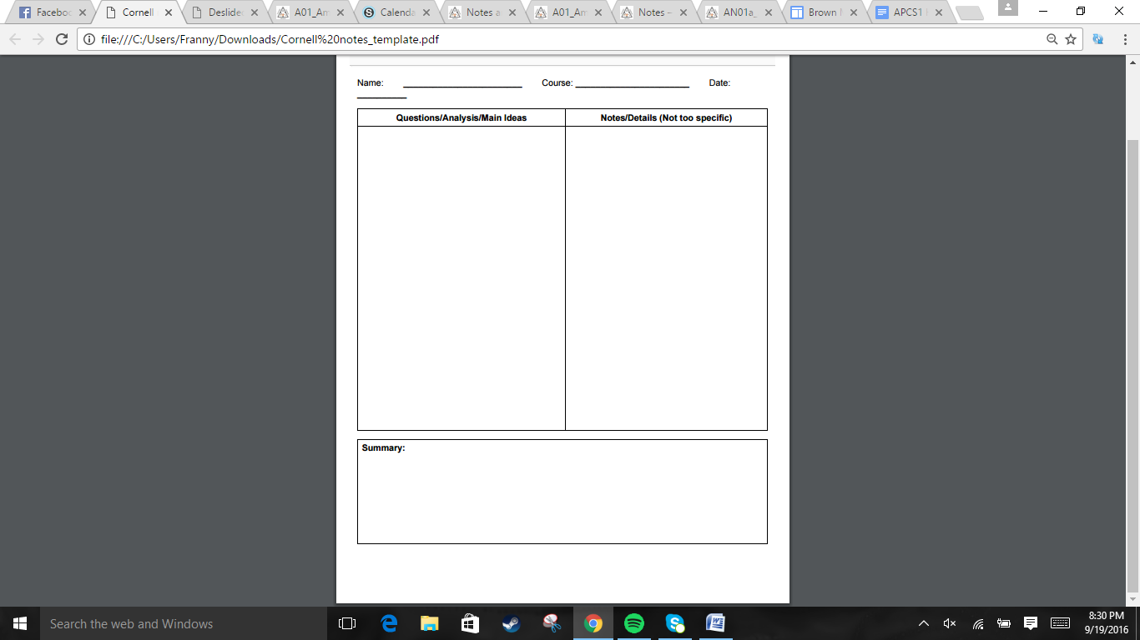  
  
  
  
  
  
  
  
  
  
  
  
  
  
  
  
  
  
  
  
  
  
  
  
  
  
  
  
  
  
  
  
  
  
  
  
  
  
  
  
  


.Jefferson's 1807 Embargo Act and the War of 1812 caused Americans to develop domestic industries instead of trading.  
. New England was especially pushed to industry. Samuel Slater was the first to establish a textile factory for thread. Lowell, Appleton, and Patrick Tracy Jackson built a weaving factory in Massachusetts. The town became a booming manufacturing center in the late 1820s, many women came to work because their farms were in decline.  
.Farmers in the north mainly farmed enough for themselves, with some raising cattle and corn to sell in cities. Slavery was dying out.  
.In the south, Whitney's invention of the cotton gin in 1793 made it easier for cotton to be processed, so nonslaveholding farmers could expand and farm it, meanwhile wealthier planters bought even more land. Cotton was king.  
.Consequently, the increased cotton farming led to demand for slavery.   
.Build transport systems, internal improvements, protective tariff, and National Bank, promoted as American System  
.1811-1838, National Road, 1825 Erie Canal  
.Tariff of 1816 by Pres Madison to protect against British selling low cost iron and textiles. Northeasterners were happy, but the South and West who did not manufacture resented it.  
.The Second Bank of the United States was mostly agreed on, chartered in 1816 for 20 years.

The industrial revolution creates a divide between northern and southern economies. The north mainly manufactured with some farming, while the south was dominated by cotton. Henry Clay proposes the American system, which under President James Madison, was generally beneficial.

Jonathan Quang US History 11/20/2016

Chapter 7: Section 1: Regional Economies Create Differences  
How does the Industrial Revolution Affect America?

What two economic systems develop?

How does Henry Clay plan to unite the two different economies?

.*Gibbons v. Ogden*, Ogden thought he had exclusive rights for the route from NY to NJ, which was granted to him by NY, but Gibbons from NJ, argued that he could also drive that route. The Supreme Court ruled that interstate commerce was to be regulated by Congress.  
.*McCulloch v. Maryland*: Was ruled against Maryland's ability to tax the Bank of the US to prevent it from failing, established that the BUS was constitutional.  
.1810*Fletcher v Peck*: the Court nullified Georgia law that prevent an individual from entering contract. 1819, *Dartmouth College v Woodward*, state of New Hamp could not interfere with charter to Dartmouth, states cannot interfere with contracts.  
.John Quincy Adams under Pres Monroe made the 1817 Rush Bagot treaty => demiltarized US-Canada border,  
Convention of 1818 => fixed US border up to Rocky Mountains 49th parallel, Adams-Onis Treaty 1819 => Florida given to US  
.In response to Europeans pushing into the Americas=> 1823 Monroe Doctrine => European powers stay out of American continents' business.  
.People are in search of economic and social gain.   
1818, Missouri Compromise, Maine admitted as free state and Missouri as a slave state to quell anger between slaveholding states and free states in Congress by maintaining 12:12 = 1:1 free to slave state ratio.

Section 2: Nationalism at Center Stage  
How does the Supreme Court boost national power?

How does Nationalism shape foreign policy?

How does Nationalism push America west?

Jonathan Quang US History 11/20/2016

The Supreme Court's decisions in certain cases showed nationalism, national interests above local/regional interests. Nationalism leads to the United States gaining more territory, fixing relationships with British Canada, and the Monroe Doctrine. As the US expands westward, tensions between slave holding states and free states increase. The Missouri Compromise tried to quell the related anger/



.There was no majority Electoral College votes in favor of Andrew Jackson or John Quincy Adams. The House of Reps decided on Adams. Followers of Jackson accused Adams of stealing the presidency, then accused him of corruption fo rappointing Clay as secretary of state. Jacksonians left the Repub. party to form the Demo-Repub. party.   
.1828 Campaign, Jackson characterized Adams as an intellectual elitist and himself as a man of humble origins. Due to the more lax voting requirements, the "man of the people" strategy led to Jackson winning by a landslide.  
.Jackson imposed 4-year terms on appointees to federal jobs, and the spoils system (old federal employees got thrown out when the presidency changes).  
.Indian Removal Act of 1830 - Federal gov funded negotiations of treaties that forced Natives to move west. Sometimes troops had to get involved.  
.The Cherokee Nation try to fight a legal battle with Worcester => *Worcester V. Georgia* 1832 in favor of Worcester, telling Georgia not to invade Cherokee lands. The federal gov find some Cherokee supporters of relocation, get them to sign it in 1835, => Trial of Tears in 1838.

Section 3: The Age of Jackson  
How does expanding democracy change politics?

What is Jackson's New Presidential Style?  
  
  
  
  
  
How did the US deal with the removal of Native Americans?

Jonathan Quang US History 11/20/2016

Lax voting requirements lead to more people being allowed to vote. This led to Jackson's "of the people" campaign strategy to let him win by the landslide. During his presidency, he reduces the permanence of federal appointees and Native Americans are forced off their land even more.



Jonathan Quang US History 11/20/2016

Section 4: States' Rights and the National Bank  
How do tariff raises bring up issues regarding States' rights?

Why does Jackson attack the National Bank?

How does Martin Van Buren deal with Jackson's legacy?

Tensions rise between the North and South due to the pressure of Tariffs and the introduction of nullifications theory. Over time, the National Bank was seen as a bank that did not help the common people. Jackson acts upon this and causes the National Bank to go bankrupt. Anger against Jackson's actions leads to the formation of the Whig Party. Then, the Panic of 1837 happens due to wildcat banks devaluing paper bills, leading to land payments only in gold and silver.

.1828 - Tariff of Abominations on imported goods => Southerners forced to buy more expensive northerner goods, see this as north getting rich off the South. VP Calhoun comes up with nullification theory, reasoning that each state had the right to reject a federal law considered unconstitutional, otherwise the state could withdraw from the Union.  
.1830, Senate listened to Hayne and Webster's debate about the Tariff and submission of laws vs open resistance, which may be considered rebellion or revolution.  
.1832, S Carolina declares the Tariffs of 1828 and 1832 as null, then threatened to secede, Jackson becomes furious => passes Force Bill of 1833 that allowed federal gov to use military against SC if they did not pay proper duties. Henry Clay proposes a gradually lowering Tariff bill in 1833 to calm tensions.  
.Jacksonians and Jackson disliked the National Bank as it benefitted stockholders and Congressmen more than the common people. Jackson wanted the treasury secretary to put the money into certain state banks = pet banks. Nicholas Biddle tries to save himself by calling in the payment of loan, eventually leads to the bank going out of business five years after its charter expiration in 1836. Anger at Jackson's tactics leads to the formation of the Whig Party in 1834.  
.Panic of 1837 caused by land payments being accepted in only gold and silver due to paper bills being devalued by wildcat banks. Van Buren's treasury he set up that only accepted gold and silver only made matters worse